HERO ANIMATION CREATIVE DIRECTION
Market Intelligence Launch
Animated Product Hero + Static Fallback |
Deliverable: An animated product hero (video/GIF) and matching static image for the Trio Market Intelligence platform, in CTA and clean variants
4 Versions: 1 with a CTA for landing page and 1 that’s just a looping GIF for decks, social, etc.
- Animated GIF with CTA
- Animated GIF no CTA
- Static Image with CTA
- Static Image no CTA

Placement: Landing page, email, social, and PowerPoint decks
EXECUTIVE SUMMARY
We need an animated product hero that brings the Trio Market Intelligence platform to life — a premium laptop-dashboard animation that conveys “live, data-rich workforce intelligence” at a glance, paired with a static image fallback for mobile and any environment where video or page-load speed is poor.
The visual model is the WorkWise homepage hero (the looping product-UI animation under “Empowering Healthcare Talent Strategy with Dynamic Excellence”): a clean laptop mockup on a branded gradient with an animated dashboard and benefit callouts. We want that same polished, product-forward feel — rebranded entirely for Trio.
Because this asset will appear across the landing page, email, social, and sales decks, it must be produced in two variants so each placement has the right ending, plus a matching static for each.
Inspiration: The Workwise.ai GIF under their “Empowering Healthcare Talent Strategy” section
https://www.workwise.ai/

PROJECT OBJECTIVE
Produce a coordinated set of hero assets that make Trio Market Intelligence look like a modern, daily-updated intelligence platform — and route demand-generation traffic to a sales demo where a CTA is appropriate.
End-Frame CTA (CTA variant): Request a Demo
Target Audience
- Healthcare CFOs
- Chief Nursing Officers
- Workforce, Talent Acquisition, and HR leaders
- Healthcare Operations leaders
Tone
Premium • Executive • Data-driven • Modern SaaS • Confident
DELIVERABLES — FOUR ASSETS
Same core animation and the same dashboard mockup throughout; the variants differ only in how they end and whether a CTA is present.
ASSET 1 — ANIMATION, CTA VERSION
The full animated hero that resolves on a “Request a Demo” end-frame and holds.
- Use: landing page hero, email, paid social
- Ends on a branded CTA card; does not loop back
ASSET 2 — ANIMATION, CLEAN VERSION
The same animation with no CTA, built to loop seamlessly (last frame flows back into the first).
- Use: PowerPoint decks, organic social, any context where a CTA would be redundant or off message
- Seamless loop; no end-frame, no button
ASSET 3 — STATIC, CTA VERSION
A single strong frame for mobile / slow-load fallback that mirrors the CTA video.
- Laptop with the full dashboard visible, one benefit callout shown, and the “Request a Demo” button present.
- Must stand on its own — not a mid-animation frame.
ASSET 4 — STATIC, CLEAN VERSION
The same hero frame without the CTA, for decks and social statics.
- Laptop + dashboard + one callout; no button
DASHBOARD MOCKUP DIRECTION
Build the dashboard as a stylized, generic representation — not a pixel-accurate reproduction of the live product.
Important: The mockup should evoke the look and feel of Trio Market Intelligence without reproducing real filters, real functionality, or the exact live UI. This keeps us free of any implied UI or functional commitments. Capture the vibe; keep the specifics deliberately illustrative.
Capture this feel
- Dark-mode premium dashboard aesthetic
- Regional U.S. map as the centerpiece, color-blocked by region
- A large headline rate figure (e.g. a “Current Job Order Bill Rate” card) and a volume figure
- Supporting modules: a historical trend line, horizontal bar comparisons, and a distribution chart
- Trio brand colors layered over the dark UI (green accents read well, matching the live tool)
Keep it generic.
- Use realistic-but-fake numbers in the style of the reference (e.g. “$89.20,” “234K”) — representative, not real reporting.
- Simplify or relabel filter rows; they should look functional without implying specific features
- No real customer data, no claims of specific capabilities in the UI itself
Visual reference — live dashboard look & feel (do not reproduce exactly):
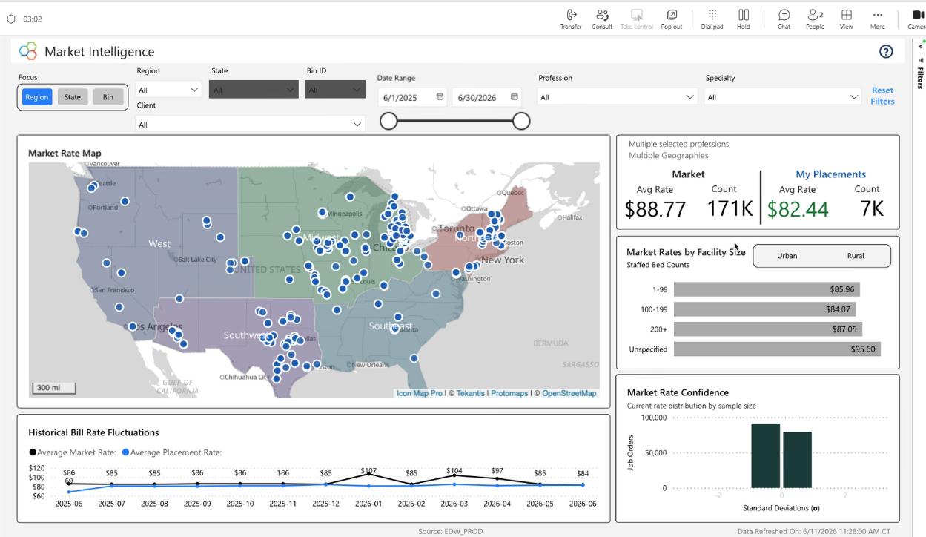
Reference: Trio Market Intelligence (representative screenshot). The branded GIF supplied separately shows the target laptop-and-gradient treatment.
ANIMATION DIRECTION
Sequence
- Open on the Trio-branded gradient background with the laptop sliding/fading into frame
- Dashboard “boots up” — modules populate in sequence (map fills, rate figure counts up, charts draw in)
- Each benefit callout animates in one at a time, and the dashboard module it names lights up in sync (geography callout → map highlights; “Facility Size” → bar module; “Historical” → trend line) — so it plays like a guided product tour
- Use 3 callouts for the short cuts (email/social), 4 for the landing-page hero (see Callout Copy)
- CTA version: resolve on the “Request a Demo” card and hold. Clean version: ease back to the opening state for a seamless loop
Style
- Smooth, premium motion — nothing frenetic; this should feel like enterprise software, not a banner ad.
- Consistent Trio branding, typography, and color across both variants
- Laptop-and-gradient treatment matching the supplied branded GIF
CALLOUT COPY —
Each animated callout pairs one of the campaign’s messaging pillars with a concrete, on-screen feature snip — the WorkWise mechanic (e.g. “Your Bill Rate vs. Market Rate by Region”).
Beat 1 — The Problem
On-screen: "National Averages Hide the Real Rate."
Visual: a flat national average line sits on screen, then the map blooms behind it showing wildly different rates by region. The single line suddenly looks naive against the spread.
Beat 2 — The Need
On-screen: "See Rates by Region, State, and Specialty."
Visual: the map drills down. Region highlights, then state, then the facility-size bars resolve underneath. Each layer adds resolution the flat average couldn't show.
Beat 3 — The Payoff
On-screen: "Know If You're Overpaying. See Where Rates Are Headed."
Visual: the benchmark card snaps in (your rate vs. market), then the trend line draws forward into the future.
End-frame (CTA version)
On-screen: "See Your Markets in Trio Market Intelligence." + Request a Demo button.
Visual: dashboard settles into its full composed state and holds.
TECHNICAL SPECIFICATIONS
Video / Animation
- Landing page hero: 16:9, 1920×1080 (provide 1280×720 lightweight cut for fast load)
- Email: short GIF or MP4, max ~600–650px wide, small file size; first frame must look complete (many clients block autoplay)
- Social: 1:1 (1080×1080) and 4:5 (1080×1350) cuts; keep callouts inside safe margins
- Formats: MP4 (H.264) primary; GIF for email; keep loops short (~8–12s) for file size
Static Fallback
- Match each video’s aspect ratios (16:9, 1:1, 4:5) so the image swaps in cleanly when video can’t load
- PNG or high-quality JPG; mobile-optimized file size
- CTA static includes the button; clean static omits it

